Odisha has jeopardized agriculture to favour industry: CAG draft report
0 Comments
Author(s): T N Vijayalakshmi
Date: Jan 24, 2013
State went on MoU signing spree without considering food security and livelihood of people
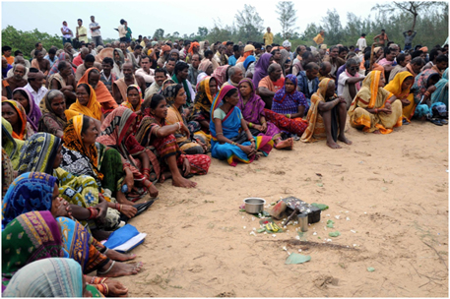Projects such as the POSCO steel plant in Jagatsinghpur district and Vedanta's bauxite mining proposal in Niyamgiri hills in Kalahandi have been stiffly opposed by local people, including affected tribals and forest dwellers (Photo by Sayantan Bera)
EXCERPT:
For the entire report please visit:
http://www.downtoearth.org.in/content/odisha-has-jeopardized-agriculture-favour-industry-cag-draft-report
Odisha has committed natural resources like land and water to industries without bearing in mind agricultural needs, says out a draft report of the Comptroller and Auditor General of India.
CAG has sought views of the state government before finalising its performance audit report—Commitment made in memorandums of understanding (MoUs) for setting up of industries in the state and acquisition/allotment of land thereof—that has slammed the Naveen Patnaik government.
Land, water and minerals being finite and scarce resources, its need-based allotment to different promoters of industries is required to be made keeping in mind the requirement in future, says the report. “The natural resources are not factors of production (only) for industrial growth but also for agriculture production on which the food security of the country rests, and these also had impact on sustainability of environment and sustenance of livelihood of citizen,” the draft copy, which is in possession of Down To Earth, says.
No assessment of availability of natural resources
Auditors have gone through scores of MoUs, minutes of government records, recorded views of departments and existing policies before observing that the state government has not made attempts to assess availability of natural resources prior to allowing industrial projects.
As many as 93 MoUs were signed by the state government with private promoters between 2001 and 2012 for setting up industries.
By March 2012, 35,793.498 acres of land (one acre equals 0.4 ha), which includes 25,012.345 acres of acquired private land and 10,781.153 of government land, was allotted to 54 companies under MoUs, 34 of which relate to the steel sector.
“But no policy or guidelines for assessing the need as well as other inputs like land, water and minerals, attracting entrepreneurs to the state through open competitive bidding, signing of MoUs with promoter companies for setting up industries in the state was formulated,” the draft performance report says.
CAG has invoked clause 9.11 of Industry Policy Resolution 2007, saying “all efforts should be made to avoid (allocation of) double cropped agricultural land and minimize R&R requirement.”
It was noticed that in 49 MoUs, commitment for providing 59,333.601 acres of land was made without any exercise to scrutinise the land category (whether agriculture, irrigated or double cropped)and no consultations were held with other departments like Revenue and Disaster Management, Water Resource, Agriculture department and district collectors. “This is indicative of the fact that the department has signed MoUs with promoter of industries and made commitments without assessing the actual availability of land, water and minerals,” the report says.
On minerals, the report says “it was noticed from minutes of 12 High Level Clearance Authority meeting held on January 27, 2010 that as against availability of 1,805.81 tonnes of total bauxite in the state, the department in different MoUs had already committed for supplying 74.61 tonnes of bauxite per annum for which the entire bauxite reserve of the state would be exhausted in next 24 years.”
Industry calls the shots
CAG has observed that industry decides where and how much land it needs.
“Checks of MoUs and concerned files revealed that promoters themselves have selected the sites and applied for acquisition subject to their suitability. The Industrial Investment Promotion Corporation of Odisha Limited (IPICOL) has assessed the requirement and based on appraisal by it, Odisha Industrial Infrastructure Development Corporation (IDCO) has filed requisition with concerned collector for acquisition of land identified by the company,” the draft report says.
It goes on to say that no exercise was conducted by government to ascertain the availability of government land to ensure barest minimum acquisition of agriculture land.
Besides, the government has not selected sites suitable for establishment of steel and power projects, mining projects, other industries considering the availability of water, mineral, government and non-agricultural land, and approachability.
“As a result, sites for setting up of industries were identified by promoter companies and got regularized by applying through IPICOL and IDCO.”

